TERMWORK 9.1

NAME : PARISHKAR SINGH

USN :2GI20CS081

DIV : B

9.1) Read a string containing 3_4 words using Scanner class object. Split it into words and for each word check if it's palindrome by writing a function isPalindrome(String the myWord, int s, int e) which return true if its palindrome else return false. Where s is start index and e is end index of the input myWord. Print it in uppercase if it is palindrome else reverse the string and print it in lowercase.  Use appropriate string functions to implement the above problem statement.

**SOURCE CODE :**

package Termworks.termwork9;  
import java.util.Scanner;  
public class tw9 {  
 public static void main(String[] args) {  
 Scanner sc = new Scanner(System.in);  
 System.out.print("Enter a string: ");  
 String str = sc.nextLine();  
 str = str +" ";  
 String subStr = "";  
 char c;  
 for(int i=0;i<str.length();i++){  
 c = str.charAt(i);  
 if(c!=' ') {  
 subStr = subStr + c;  
 }  
 else {  
 checkPalindrome(subStr,0,subStr.length()-1);  
 subStr = "";  
 }  
 }  
 }  
 public static void checkPalindrome(String str,int s,int e) {  
 String revStr = reverse(str,s,e);  
 if(revStr.equals(str)) {  
 System.out.println(str.toUpperCase());  
 }  
 else {  
 System.out.println(revStr.toLowerCase());  
 }  
 }  
 public static String reverse(String str,int s,int e) {  
 String substr="";  
 for(int i=e;i>=s;i--) {  
 substr = substr+str.charAt(i);  
 }  
 return substr;  
 }  
}

**Case-1:**

**Enter a string: nitin speaks malayalam at his home**

**NITIN**

**skaeps**

**MALAYALAM**

**ta**

**sih**

**emoh**

**Case-2:**

**Enter a string: my name is aniket**

**ym**

**eman**

**si**

**tekina**

TERMWORK 9.2

NAME : PARISHKAR SINGH

USN :2GI20CS081

DIV : B

9.3) Write a Java program that creates a simple book database (use an array of N objects). Each book is represented with a ID, title, author (First Name & last name), Genre (category – technical, Sci Fi, Fiction, Comedy etc) and a Publisher name. Define methods to perform the following tasks:

1. Given a title, returns a status to indicate whether or not the book exists in database.
2. Given a string “str”, lists the details of all the books whose title contains str.
3. Given a genre, lists publishers who have published books in that genre.
4. Given a character “c”, lists all authors who name starts with “c”.
5. import java.util.*;  
     
   class Book {  
    String id, title, author, genre, pubname;  
     
    Book() {  
    Scanner in = new Scanner(System.*in*);  
    System.*out*.println("ID:");  
    id = in.nextLine();  
    System.*out*.println("Title:");  
    title = in.nextLine();  
    System.*out*.println("Author:");  
    author = in.nextLine();  
    System.*out*.println("genre:");  
    genre = in.nextLine();  
    System.*out*.println("Publisher name:");  
    pubname = in.nextLine();  
    }  
     
    boolean searchTitle(Book b[], String key, int n) {  
    for (int i = 0; i < n; i++) {  
    if (b[i].title.equals(key))  
    return true;  
    }  
    return false;  
    }  
     
    void getpub_bygenre(Book b[], String g, int n) {  
     
    for (int i = 0; i < n; i++) {  
    if (b[i].genre.equals(g)) {  
    System.*out*.println("The books published in " + g + " are " + b[i].pubname);  
    }  
    }  
     
    }  
     
    void getauthor_bychar(Book b[], char c, int n) {  
    for (int i = 0; i < n; i++) {  
    if (b[i].author.charAt(0) == c)  
    System.*out*.println(b[i].author);  
    }  
    }  
   }  
     
   public class Main {  
    public static void main(String args[]) {  
    int n;  
    Scanner in = new Scanner(System.*in*);  
    System.*out*.println("Enter the number of books:");  
    n = in.nextInt();  
    Book b[] = new Book[n];  
    Book b1[];  
    b1 = b;  
    for (int i = 0; i < n; i++) {  
    System.*out*.println("\nBook " + (i + 1));  
    b[i] = new Book();  
    }  
    String k, g;  
    System.*out*.println("Enter Book title for search");  
     
    k = in.next();  
     
    if (b1[0].searchTitle(b, k, n))  
    System.*out*.println("The book is Found");  
    else  
     
    System.*out*.println("The book is Not found");  
     
    System.*out*.println("Enter desired genre");  
    g = in.next();  
    b1[0].getpub_bygenre(b, g, n);  
     
    char c;  
    System.*out*.println("Enter a Character:");  
    c = in.next().charAt(0);  
    System.*out*.println("Authors whose name start with " + c + " are:");  
    b1[0].getauthor_bychar(b, c, n);  
    }  
   }

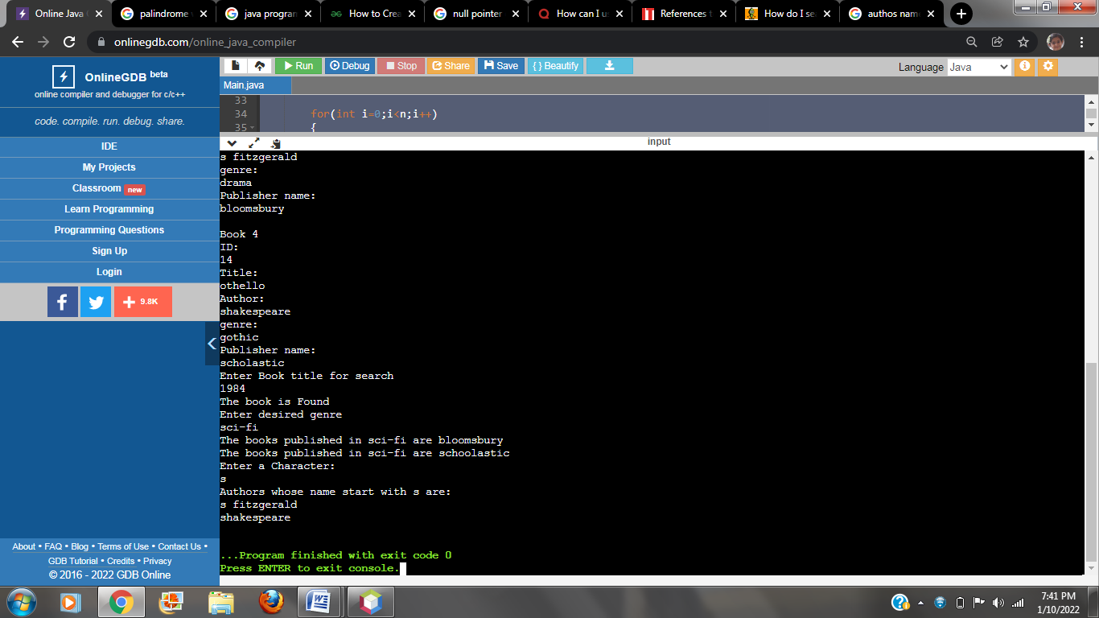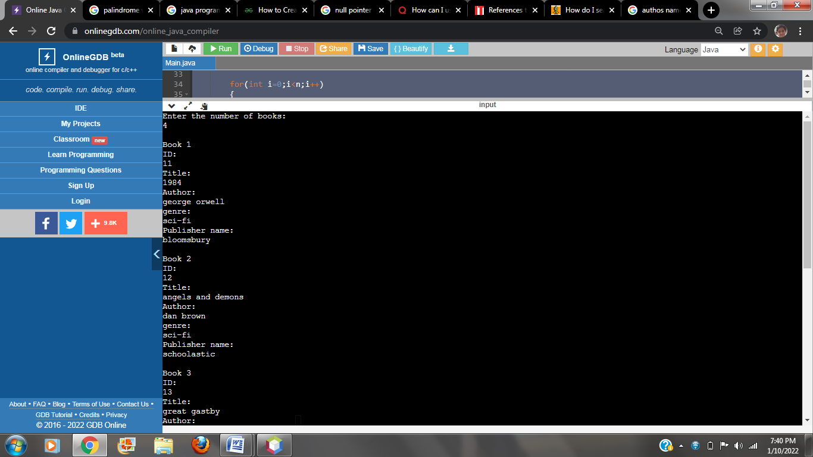**OUTPUT:-**

TERMWORK 10.1

NAME : PARISHKAR SINGH

USN :2GI20CS081

DIV : B

10.1 ) Design and develop a GUI application to accepts student details as shown in the GUI below. Allow the user to add records one after the other. Once the user clicks on close, compute the average score and display the details using JTable component.

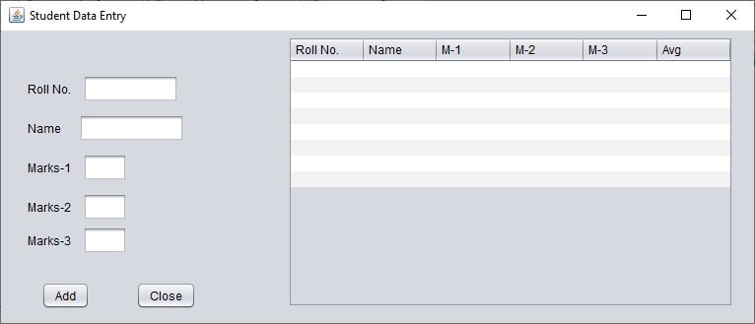

Rename close as “Summarize”

import java.util.ArrayList;  
  
  
public class StudentData extends  
  
 javax.swing.JFrame {  
 class StudentRecord {  
String name;   
 int rNo, m1, m2, m3;  
  
 StudentRecord(int rNo, String name, int m1, int m2,  
 int m3) {  
 this.name = name;  
  
 this.rNo =  
 rNo;  
 this.m1 = m1;  
 this.m2 = m2;  
 this.m3 = m3;  
  
 }  
 ArrayList<StudentRecord> records = new ArrayList<StudentRecord>();  
  
 public StudentData() {  
 initComponents();  
  
 }  
  
  
*/\*\** @SuppressWarnings("unchecked")  
*// <editor-fold defaultstate="collapsed" desc="Generated Code"> private void initComponents() {* jLabel1 =new  
 javax.swing.JLabel();jLabel2 =  
 new javax.swing.JLabel();jLabel3  
=new javax.swing.JLabel();  
 jLabel4 =new  
  
 javax.swing.JLabel();  
 jLabel5 =new javax.swing.JLabel();  
 jTextField1 =new  
 javax.swing.JTextField();  
 jTextField2 =new  
 javax.swing.JTextField();  
 jTextField3 =new  
 javax.swing.JTextField();  
 jTextField4 =new  
 javax.swing.JTextField();  
 jTextField5 =new  
 javax.swing.JTextField();jButton1  
=new javax.swing.JButton();  
 jButton2 =new  
 javax.swing.JButton();  
 jScrollPane1 =new javax.swing.JScrollPane();  
  
 jTable1 =new javax.swing.JTable();  
  
  
 setDefaultCloseOperation(javax.swing.WindowConstants.EXIT_ON_  
 CLOSE);  
  
 setTitle("Student Details");  
  
jLabel1.setText(" Roll No. :");  
  
  
  
jLabel2.setText("Name :");  
  
  
jLabel3.setText("Marks 1 :");  
  
  
jLabel4.setText(" Marks 2 :");  
  
  
jLabel5.setText(" Marks 3 :");  
  
  
jTextField4.addActionListener(new  
  
 java.awt.event.ActionListener()  
  
 {  
 public void actionPerformed (java.awt.event.ActionEvent evt){  
  
 jTextField4ActionPerformed(evt);  
 }  
 });  
  
jButton1.setText("Add");  
  
jButton1.addActionListener(new  
 java.awt.event.ActionListener()  
  
 {  
 public void actionPerformed (java.awt.event.ActionEvent evt)  
 {  
  
 jButton1ActionPerformed(evt);  
  
  
 }  
  
 }  
  
 ;  
  
  
jButton2.setText("Summarize");  
  
jButton2.addActionListener(new  
 java.awt.event.ActionListener()  
  
 {  
 public void actionPerformed (java.awt.event.ActionEvent evt)  
  
 }  
  
 jButton2ActionPerformed(evt);  
  
 }  
  
};  
  
  
  
jTable1.setFont(new java.awt.Font("Calibri",0,16));  
  
*// NOI18N jTable1.setModel(new* javax.swing.table.DefaultTableModel(  
  
 new Object[][]{  
 {null,null,null,null,null,null},  
  
 {null,null,null,null,null,null},  
  
 {null,null,null,null,null,null},  
  
 {null,null,null,null,null,null},  
  
 {null,null,null,null,null,null},  
  
 {null,null,null,null,null,null},  
  
 {null,null,null,null,null,null},  
  
 {null,null,null,null,null,null},  
  
 {null,null,null,null,null,null},  
  
 {null,null,null,null,null,null}  
 },  
  
 new String[]{  
 "Roll No.","Name","M-1","M-2","M-3","Average"  
 }  
 ));  
  
  
 jScrollPane1.setViewportView(jTable1);  
  
  
 javax.swing.GroupLayout layout=new  
  
 javax.swing.GroupLayout(getContentPane());  
  
 getContentPane().setLayout(layout);  
  
 layout.setHorizontalGroup(  
  
 layout.createParallelGroup(javax.swing.GroupLayout.Alignment.LEADING)  
  
 .addGroup(layout.createSequentialGroup()  
  
  
 .addGap(38,38,38)  
  
 .addGroup(layout.createParallelGroup(javax.swing.GroupLayout.Alignment.LEADING)  
  
  
 .addGroup(layout.createSequentialGroup()  
  
 .addComponent(jButton1)  
  
 .addGap(41,41,41)  
  
 .addComponent(jButton2))  
  
 .addGroup(layout.createSequentialGroup()  
  
 .addGroup(layout.createParallelGroup(javax.swing.GroupLayout.Alignment.TRAILING)  
  
 .addComponent(jLabel5)  
  
 .addComponent(jLabel4)  
  
 .addComponent(jLabel3)  
  
 .addComponent(jLabel2)  
  
 .addComponent(jLabel1))  
  
 .addGap(33,33,33)  
 .addGroup(layout.createParallelGroup(javax.swing.GroupLayout.Alignment.LEADING)  
  
 .addGroup(layout.createParallelGroup(javax.swing.GroupLayout.Alignment.LEADING,  
 false)  
  
  
 .addComponent(jTextField2,  
  
 javax.swing.GroupLayout.DEFAULT_SIZE,76,Short.MAX_VALUE)  
  
 .addComponent(jTextField3)  
  
 .addComponent(jTextField4)  
  
 .addComponent(jTextField5))  
  
 .addComponent(jTextField1,  
  
 javax.swing.GroupLayout.PREFERRED_SIZE,93,  
  
 javax.swing.GroupLayout.PREFERRED_SIZE))))  
  
 .addGap(18,18,18)  
 .  
 addComponent(jScrollPane1,  
  
 javax.swing.GroupLayout.PREFERRED_SIZE,626,  
  
 javax.swing.GroupLayout.PREFERRED_SIZE)  
  
 .addContainerGap(96,Short.MAX_VALUE))  
 );  
  
  
 layout.setVerticalGroup(  
 layout.createParallelGroup(javax.swing.GroupLayout.Alignment.LEADING)  
 .  
  
 addGroup(layout.createSequentialGroup()  
  
 .addGap(47,47,47)  
  
 .addGroup(layout.createParallelGroup(javax.swing.GroupLayout.Alignment.LEADING)  
 .addComponent(jLabel1)  
  
 .addComponent(jTextField1,  
 javax.swing.GroupLayout.PREFERRED_SIZE,  
  
 javax.swing.GroupLayout.DEFAULT_SIZE,  
  
 javax.swing.GroupLayout.PREFERRED_SIZE))  
 .addPreferredGap(javax.swing.LayoutStyle.ComponentPlacement.RELATED)  
  
 .addGroup(layout.createParallelGroup(javax.swing.GroupLayout.Alignment.LEADING)  
  
 .addComponent(jLabel2)  
 .addComponent(jTextField2,  
 javax.swing.GroupLayout.PREFERRED_SIZE,  
 javax.swing.GroupLayout.DEFAULT_SIZE,  
 javax.swing.GroupLayout.PREFERRED_SIZE))  
  
 .addPreferredGap(javax.swing.LayoutStyle.ComponentPlacement.RELATED)  
  
 .addGroup(layout.createParallelGroup(javax.swing.GroupLayout.Alignment.BASELINE)  
  
  
 .addComponent(jLabel3)  
  
 .addComponent(jTextField3,  
 javax.swing.GroupLayout.PREFERRED_SIZE,  
 javax.swing.GroupLayout.DEFAULT_SIZE,  
 javax.swing.GroupLayout.PREFERRED_SIZE))  
  
 .addGap(18,18,18)  
  
 .addGroup(layout.createParallelGroup(javax.swing.GroupLayout.Alignment.BASELINE)  
  
 .addComponent(jLabel4)  
  
 .addComponent(jTextField4,  
 javax.swing.GroupLayout.PREFERRED_SIZE,  
 javax.swing.GroupLayout.DEFAULT_SIZE,  
 javax.swing.GroupLayout.PREFERRED_SIZE))  
  
 .addPreferredGap(javax.swing.LayoutStyle.ComponentPlacement.UNRELATED)  
  
 .addGroup(layout.createParallelGroup(javax.swing.GroupLayout.Alignment.BASELINE)  
 .addComponent(jLabel5)  
  
 .addComponent(jTextField5  
 ,javax.swing.GroupLayout.PREFERRED_SIZE,  
 javax.swing.GroupLayout.DEFAULT_SIZE,  
 javax.swing.GroupLayout.PREFERRED_SIZE))  
  
  
 .addGap(99,99,99)  
  
 .addGroup(layout.createParallelGroup(javax.swing.GroupLayout.Alignment.BASELINE)  
 .addComponent(jButton1)  
  
 .addComponent(jButton2))  
  
 .addContainerGap(javax.swing.GroupLayout.DEFAULT_SIZE,Short.MAX_VALUE))  
  
 .addGroup(layout.createSequentialGroup()  
  
 .addComponent(jScrollPane1,  
 javax.swing.GroupLayout.PREFERRED_SIZE,  
  
 javax.swing.GroupLayout.DEFAULT_SIZE,  
  
 javax.swing.GroupLayout.PREFERRED_SIZE)  
  
 .addGap(0,103,Short.MAX_VALUE))  
 );  
  
  
 pack();  
  
 }  
  
  
private void jTextField4ActionPerformed(java.awt.event.ActionEvent evt){  
  
  
 }  
  
  
private void  
  
 jButton2ActionPerformed(java.awt.event.ActionEvent evt){  
  
 int rowCount=0;  
  
 for(StudentRecord s:records){  
 jTable1.setValueAt(s.rNo,  
 rowCount,0);  
  
 jTable1.setValueAt(s.name,rowCount,1);  
  
 jTable1.setValueAt(s.m1,rowCount,2);  
  
 jTable1.setValueAt(s.m2,rowCount,3);  
  
 jTable1.setValueAt(s.m3,  
 rowCount,4);float avg=  
 (s.m1+s.m2+s.m3)/3.0f;  
  
  
 jTable1.setValueAt(String.format("%.2f",avg),  
  
 rowCount,5);rowCount++;  
 }  
 }  
  
  
private void jButton1ActionPerformed(java.awt.event.ActionEvent evt){  
 StudentRecord S1=snewStudentRecord(Integer.parseInt(jTextField1.getText()),  
 jTextField2.getText(),  
  
 Integer.parseInt(jTextField3.getText()),  
  
 Integer.parseInt(jTextField4.getText()),  
  
 Integer.parseInt(jTextField5.getText()));  
  
  
 records.add(s1);  
  
 jTextField1.setText("");  
  
 jTextField2.setText("");  
  
 jTextField3.setText("");jTextField4.setText("");jTextField5.setText("");  
 }  
  
public static void main(String args[]){  
  
 *\*/* try{  
 for  
  
 (javax.swing.UIManager.LookAndFeelInfo info:  
  
  
 javax.swing.UIManager.getInstalledLookAndFeels()){  
  
  
 if("Nimbus".equals(info.getName())){  
  
 javax.swing.UIManager.setLookAndFeel(info.getClass  
 Name());break;  
 }  
 }  
 }  
 catch(ClassNotFoundException ex){  
  
  
 java.util.logging.Logger.getLogger(StudentData.class.getName()).log(java.util.logging.Level.SEVERE,null,ex);  
 }catch(InstantiationException ex){  
  
  
 java.util.logging.Logger.getLogger(StudentData.class.getName()).log(java.util.logging.Level.SEVERE,null,ex);  
 }  
  
 catch(IllegalAccessException ex){  
  
  
 java.util.logging.Logger.getLogger(StudentData.class.getName()).log(java.util.logging.Level.SEVERE,null,ex);  
 }  
 catch(javax.swing.UnsupportedLookAndFeelException ex){  
  
  
 java.util.logging.Logger.getLogger(StudentData.class.getName()).log(java.util.logging.Level.SEVERE,null,ex);  
 }

java.awt.EventQueue.invokeLater(new  
  
 Runnable(){  
  
public void run(){  
  
 new StudentData().setVisible(true);  
 }  
 });  
 }  
  
  
*// Variables declaration - do not modify private*privatejavax.swing.JButton jButton1;  
  
private javax.swing.JButton  
  
 jButton2;   
  
  
  
private javax.swing.JLabel jLabel1;  
  
private javax.swing.JLabel  
  
 jLabel2;   
  
private javax.swing.JLabel jLabel3;  
  
private javax.swing.JLabel  
  
 private jLabel4;  
  
private javax.swing.JLabel jLabel5;  
  
private javax.swing.JScrollPane  
  
 jScrollPane1;   
  
private javax.swing.JTable jTable1;  
  
private javax.swing.JTextField  
  
 jTextField1;   
  
private javax.swing.JTextField jTextField2;  
  
  
private javax.swing.JTextField jTextField3;   
private javax.swing.JTextField jTextField4;

private javax.swing.JTextField jTextField5;  
  
  
 }

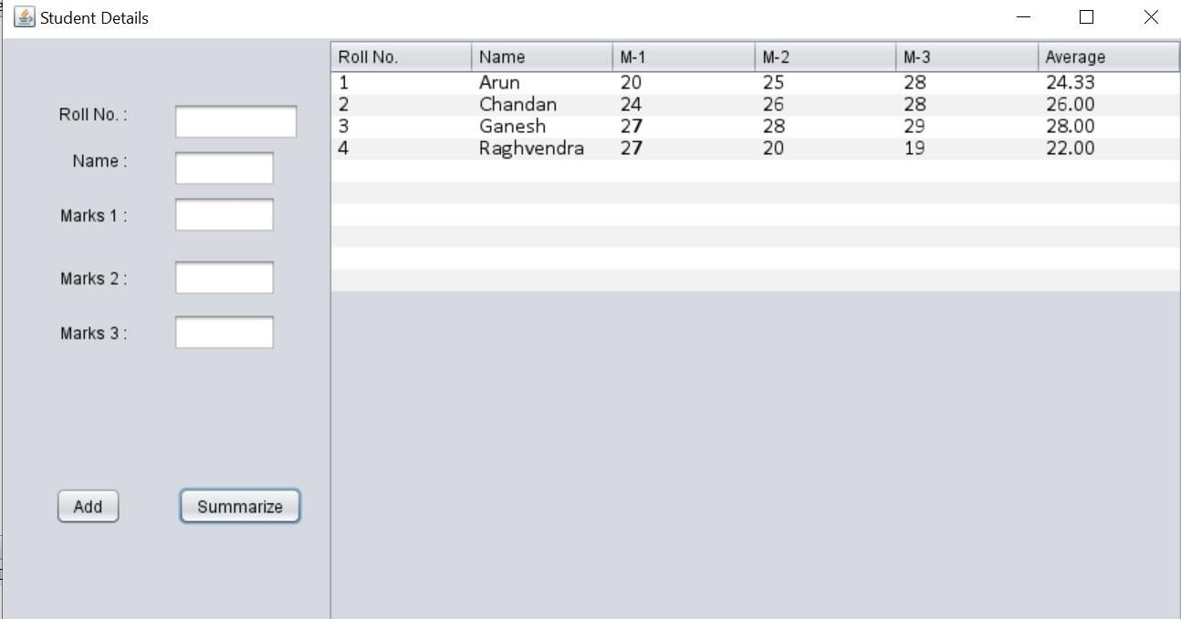

TERMWORK 10.2

NAME : PARISHKAR SINGH

USN :2GI20CS081

DIV : B

Design and implement a Home loan Emi calculator using appropriate Swing components. The GUI should like as under:

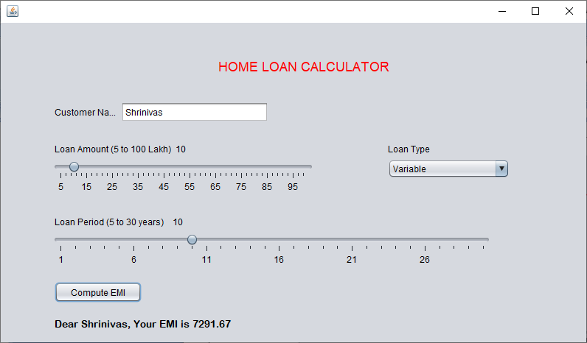

# Code:

import java.awt.*;  
import java.awt.event.*;  
import javax.swing.*;  
  
public class emiCalculator extends JFrame {  
  
 private JTextField jtfInvestmentAmount;  
 private JTextField jtfAnnualInterestRate;  
 private JTextField jtfNumberOfYears;  
 private JTextField jtfFutureValue;  
 private JButton jbtCompute;  
 private JButton jbtReset;  
  
 public emiCalculator() {  
  
 setTitle("Loan Calculator");  
 setDefaultCloseOperation(JFrame.*EXIT_ON_CLOSE*);  
 setSize(500, 300);  
 setLocationRelativeTo(null);  
 setLayout(new GridLayout(5, 2, 5, 5));  
  
 JLabel jlInvestmentAmount = new JLabel(" Investment Amount");  
 JLabel jlNumberOfYears = new JLabel(" Number of Years");  
 JLabel jlAnnualInterestRate = new JLabel(" Annual Interest Rate");  
 JLabel jlFutureValue = new JLabel(" Future Value");  
  
 jtfInvestmentAmount = new JTextField();  
 jtfNumberOfYears = new JTextField();  
 jtfAnnualInterestRate = new JTextField();  
 jtfFutureValue = new JTextField();  
 jtfFutureValue.setEditable(false);  
  
 jbtCompute = new JButton("Compute");  
 jbtReset = new JButton("Reset");  
  
 add(jlInvestmentAmount);  
 add(jtfInvestmentAmount);  
 add(jlNumberOfYears);  
 add(jtfNumberOfYears);  
 add(jlAnnualInterestRate);  
 add(jtfAnnualInterestRate);  
 add(jlFutureValue);  
 add(jtfFutureValue);  
 add(jbtCompute);  
 add(jbtReset);  
  
  
 ListenerClass listener = new ListenerClass();  
 jbtCompute.addActionListener(listener);  
 jbtReset.addActionListener(listener);  
  
 setVisible(true);  
 }  
  
 public static void main(String[] args) {  
 new emiCalculator();  
 }  
  
 private void computeValue() {  
 try {  
 double annualInterestRate = Double.*parseDouble*(jtfAnnualInterestRate.getText());  
 double monthlyInterestRate = annualInterestRate / 1200.0;  
 int NumberOfYears = Integer.*parseInt*(jtfNumberOfYears.getText());  
 double investmentAmount = Double.*parseDouble*(jtfInvestmentAmount.getText());  
 double futureValue = investmentAmount * Math.*pow*(1.0 + monthlyInterestRate, NumberOfYears * 12);  
 jtfFutureValue.setText(String.*format*("%.2f", futureValue));  
 } catch (Exception e) {  
 JOptionPane.*showMessageDialog*(null, " Please enter numeric values.");  
 }  
 }  
  
 private void resetForm() {  
 jtfInvestmentAmount.setText("");  
 jtfAnnualInterestRate.setText("");  
 jtfNumberOfYears.setText("");  
 jtfFutureValue.setText("");  
 }  
  
 private class ListenerClass implements ActionListener {  
 public void actionPerformed(ActionEvent e) {  
 if (e.getSource() == jbtCompute) {  
 computeValue();  
 }  
 if (e.getSource() == jbtReset) {  
 resetForm();  
 }  
 }  
 }  
}

# Output:



**Parishkar singh**

**2gi20cs081**

**Termwork 10**

**11-jan-22**

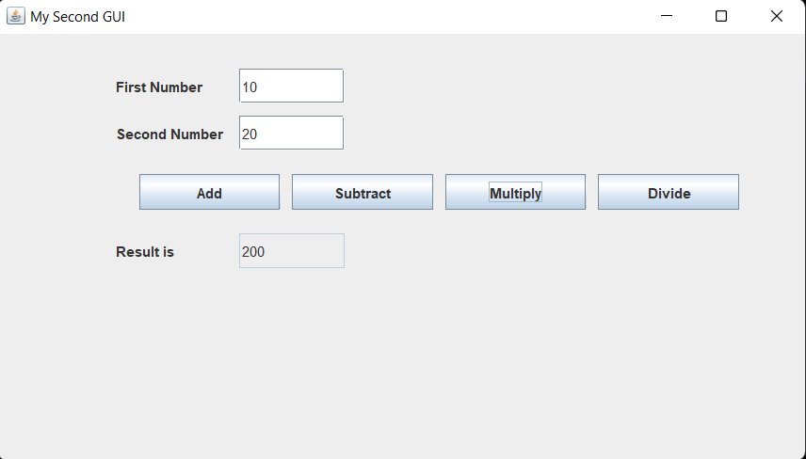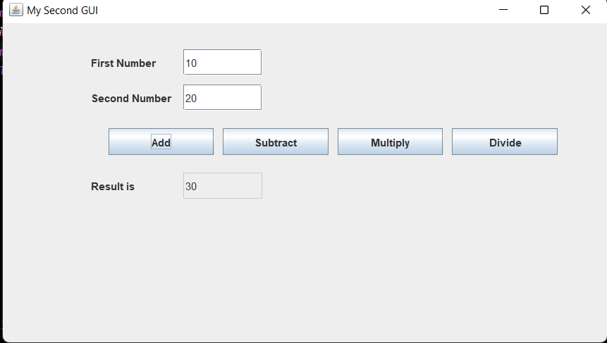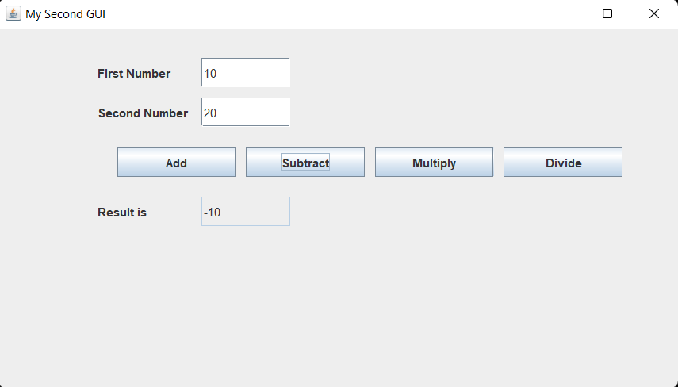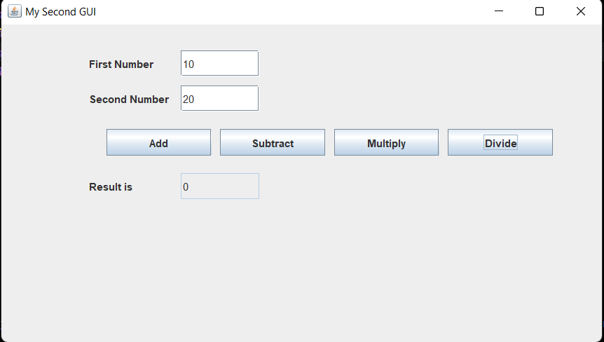

div

sub

add

multiply